Mapping Obesity: Its Essential Drivers and Systems
Introduction
Obesity is an increasingly pressing global issue, with significant health challenges and substantial socioeconomic burdens (5). It drives up healthcare costs, reduces quality of life, and contributes to a variety of adverse consequences (5). Obesity can lead to increased absenteeism, reduced productivity, and higher disability claims, affecting economic output and contributing to financial strain on businesses and economies (6). Excess weight can lead to physical limitations, reduced mobility, joint pain, and decreased physical endurance, affecting daily activities and overall quality of life (6). Individuals with obesity may face social stigma and discrimination, impacting their self-esteem, social interactions, and social opportunities, including employment (1). Obesity can affect entire families, influence health habits, dynamics, and lifestyle choices, which can contribute to the continuation of obesity trends (1).

Additionally, the growing prevalence of comorbidities from obesity can further impact individuals and reverberate across generations. Therefore, it is critical to understand the systematic causal relationships, feedback loops that contribute to obesity. By viewing obesity through an integrated systems lens, we can craft holistic solutions by addressing the root causes.

The complexity of obesity arises from the intricate interplay among various interconnected factors, which significantly influences its progression and outcomes. Addressing this issue requires a comprehensive examination of the factors driving obesity and the identification of key leverage points that can help counteract the rising trend in weight gain. Employing a whole-systems approach allows us to unravel these intricate interactions and gain a deeper understanding of how these factors collectively drive the obesity epidemic. This framework not only skillfully allows us to consider the subtle relationships between these components but also illuminates a pathway for developing more effective prevention and management strategies for obesity.
This essay seeks to elucidate the complexities of obesity by analyzing and integrating insights from a broad array of research studies. Its approach involves mapping out all the critical drivers and systematically unravelling the intricate web that characterizes obesity.
- Genetics & Biology
Genetic predispositions can increase one’s susceptibility to obesity, but environmental factors play a crucial role in determining whether these predispositions actually lead to obesity. For instance, the FTO gene, associated with higher body fat, can affect satiety signals, leading to increased hunger and higher calorie consumption (7). Similarly, variations in the KLF14 gene can impact fat cell formation and proliferation, contributing to obesity (7). The MC4R gene regulates appetite and energy balance, and mutations can impair calorie burning and promote fat storage (7). Obesity is influenced by multiple genetic variants. Genome-wide association studies (GWAS) identify how certain genetic variants link to obesity, but environmental and epigenetic factors also play a significant role (7). The polygenic risk score (PRS) combines multiple genetic risk factors to estimate an individual’s overall likelihood of developing obesity. This helps tailor personalized interventions and enables closer monitoring to prevent weight gain and associated metabolic issues (9). 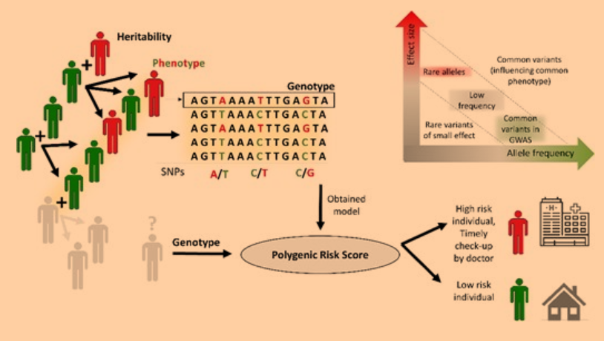
Figure 1: Schematic Representation of Polygenic Risk Score. This figure illustrates the key components in assessing genetic risk. Genetic variants are depicted by genotype coding, with arrows indicating the influence on polygenic risk score—whether high or low—heritability, and phenotype. Additionally, a graph shows the cumulative frequency of multiple gene variants and their predisposition to obesity, providing a comprehensive view of how genetic factors contribute to overall risk.

- Habitual & Psychological Factors Impacting Obesity
Stress can significantly affect metabolic and neurobiological processes. During periods of stress, elevated cortisol levels can lead to increased gluconeogenesis and upregulation of corticotropin-releasing factor (CRF) in the amygdala and other limbic regions. This hormonal imbalance can result in impaired reward functioning (1). Stress also produces higher levels of ghrelin and cortisol, which provoke cravings and consumption of more palatable foods (1). Stress-induced eating can be influenced by the nature and duration of the stressor, the availability of calorie-dense and appealing foods, how long these foods are accessible, and individual's hunger and satiety levels (1). Escalating obesity rates in advanced economies are largely attributed to sweetened beverages and calorie-rich foods. Individuals with lower economic status tend to adopt less healthier eating habits due to the cheaper cost of unhealthy food (8).
Nowadays, food choices are largely driven by appeal. Advertisers use appealing visuals, persuasive language, and emotional connections to sell more profitable food products. Additionally, cultural background, upbringing and beliefs shape food choices significantly (8).
- Neurobiology
The hypothalamus regulates hunger, satiety, and energy balance by processing signals from hormones like ghrelin and leptin. Ghrelin stimulates appetite and enhances the pleasure of eating, which promotes food-seeking behaviors. The brain’s reward system, including the ventral striatum and nucleus accumbens, supports these food-related behaviors. The prefrontal cortex, which manages decision-making and self-control, can be influenced by ghrelin, affecting impulse control and food intake, potentially leading to increased food consumption. In contrast, leptin works to suppress appetite by activating POMC neurons and inhibiting NPY neurons. However, in obesity, leptin resistance can diminish its effectiveness. Together, leptin and ghrelin regulate appetite and energy balance through a system of opposing signals, with leptin addressing long-term energy balance and ghrelin managing short-term hunger (4).
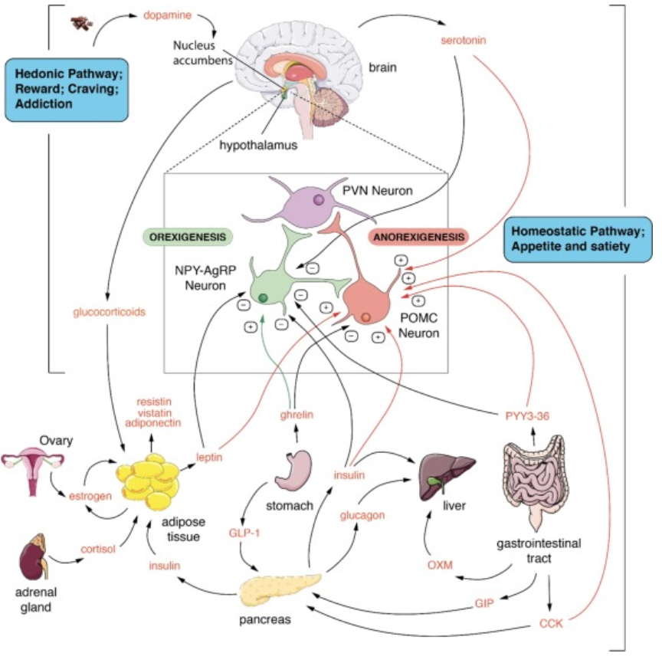
Figure 2: Systems Diagram Illustrating Hedonic and Homeostatic Pathways. This diagram represents the complex interplay between the brain's hedonic (reward, craving, addiction) pathways and homeostatic (appetite and satiety) pathways. It highlights the signaling interactions between these neural pathways and various organs, including the liver, stomach, pancreas, adipose tissue, and gastrointestinal tract, showcasing how these systems collectively influence behavior and metabolic regulation (Lustig et al., 2022).

Consuming diets containing processed foods, sugars, and unhealthy fats promotes the growth of harmful bacteria which damages gut lining, leading to increased intestinal permeability (leaky gut). Harmful bacteria can produce toxins and trigger gut inflammation inducing metabolic disturbances that affect appetite-regulating hormones. These mechanisms create a cycle where harmful bacteria, inflammation, and metabolic disturbances reinforce each other, leading to increased fat accumulation and obesity (3).
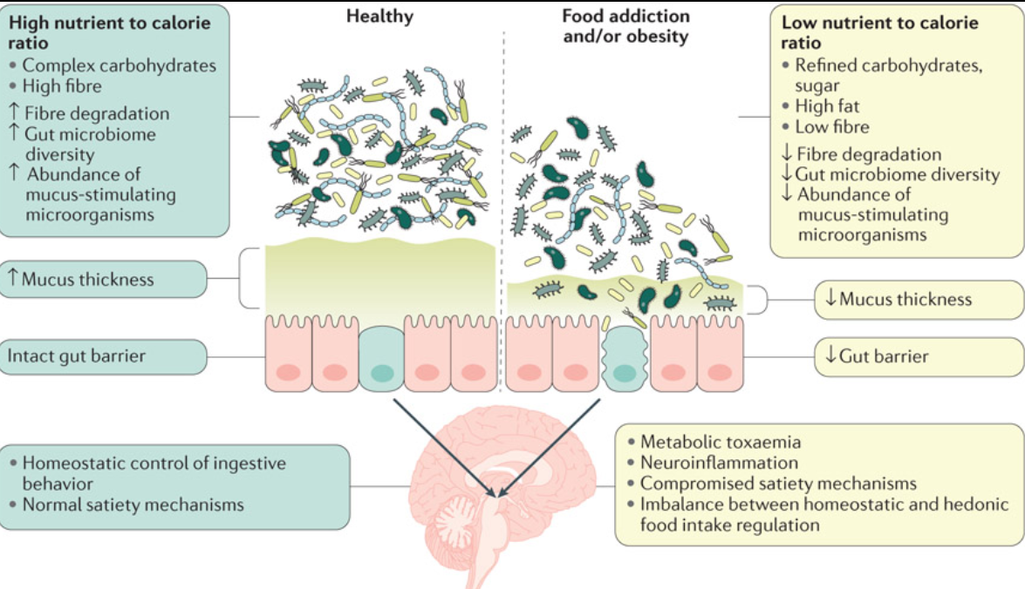
Figure 3: Gut Microbiome and Metabolic Toxemia in Healthy and Obese Individuals. This diagram contrasts the gut microbiome's role in metabolic health between healthy and obese individuals. It illustrates the compromised satiety mechanisms, weakened gut barrier, and dysbiosis (unhealthy microbiome) associated with obesity, highlighting how these factors contribute to metabolic toxemia and impaired metabolic function (Gupta et al., 2020).
- Exercise
A sedentary lifestyle, characterized by insufficient physical activity, significantly amplifies the risk of obesity. Insufficient physical activity reduces energy expenditure, leading to a mismatch between calorie intake and calorie burning. This imbalance contributes to excess energy being stored as body fat, resulting in weight gain and increased obesity risk. Low physical activity also impairs metabolic processes, including glucose and lipid metabolism (10).
Technologies
Through combining genomic, proteomic, metabolomic, and other omics data, we can gain a more comprehensive understanding of the underlying biological factors that contribute to obesity risk. Computational models provide opportunities to assess how slight changes can assert power on the whole. For instance, if we create a mathematical model with energy intake, expenditure and storage as outputs, diet composition, physical activity, access to beneficial resources like healthy foods, therapy as inputs we can predict whether individuals may have a higher obesity risk. Through mobile applications and paired devices, we can collect real-time data on these aspects easily. Analyzing these critical nodes and pathways as well as tracking biological data over time allows us to develop methods to combat the increasing obesity trends by figuring out solutions. Further validation by conducting experiments and systematic literature reviews allows us to strengthen credibility. Advanced integration of these datasets with algorithms and machine learning can further reveal subtle patterns and trends that are difficult to catch and manually discern.
Conclusion
By viewing obesity as a multifaceted puzzle, with interconnected pieces including lifestyle choices, psychological influences, genetic predispositions, biological factors and cultural norms, we find that each piece intertwines and influences the others. For example, access to healthy food can be influenced by wealth/socioeconomic status, stress can impact dietary choices, lifestyle, behaviors and can cause hormone disruptions. These systems are circular. Further, shared beliefs, perception and self-image can interfere with the motivation to get fitter and eat healthier.
Mapping obesity with complex computational models and mathematical simulations allows us to predict changes in body weight and fat mass more accurately. Further, mobile apps and paired devices support self- monitoring physical activity levels, nutrient/food intake, weight fluctuations concurrently. Advanced algorithms and machine learning can then analyze collected datasets to uncover complex patterns and interactions that may be challenging to detect through manual analysis.
Bibliography
- Harun Kundi, Amin ZM, Friedman M, Hagan K, Sadeer Al-Kindi, Javed Z, et al. Association of Obesity With Psychological Distress in Young Adults. JACC Advances. 2024 Aug 1;3(8):101115–5.
- Drewnowski, A. (2009). Obesity, diets, and social inequalities. Nutrition Reviews, 67. https://doi.org/10.1111/j.1753-4887.2009.00157.x
- Gupta A, Osadchiy V, Mayer EA. Brain–gut–microbiome interactions in obesity and food addiction. Nature Reviews Gastroenterology & Hepatology. 2020 Aug 27;17(11):655–72.
4. Hopkins M, Blundell John E. Energy balance, body composition, sedentariness and appetite regulation: pathways to obesity. Clinical Science [Internet]. 2016 Aug 8;130(18):1615–28. Available from: http://eprints.whiterose.ac.uk/112990/1/Energy%20Balance%20Body%20Composition%20and%20Appetite%20Regulation.%20Pathways%20to%20Obesity_Symplectic%20Elements%20.pdf
5. Lehnert T, Sonntag D, Konnopka A, Riedel-Heller S, König HH. Economic costs of overweight and obesity. Best Practice & Research Clinical Endocrinology & Metabolism [Internet]. 2013 Apr;27(2):105–15. Available from: https://www.sciencedirect.com/science/article/pii/S1521690X1300016X
6. Lustig RH, Collier D, Kassotis C, Roepke TA, Kim MJ, Blanc E, et al. Obesity I: Overview and molecular and biochemical mechanisms. Biochemical Pharmacology. 2022 May;199:115012.
7. Novelli G, Cassadonte C, Sbraccia P, Michela Biancolella. Genetics: A Starting Point for the Prevention and the Treatment of Obesity. Nutrients. 2023 Jun 17;15(12):2782–2.
8. Sadeghirad B, Duhaney T, Motaghipisheh S, Campbell NRC, Johnston BC. Influence of unhealthy food and beverage marketing on children’s dietary intake and preference: a systematic review and meta-analysis of randomized trials. Obesity Reviews. 2016 Jul 18;17(10):945–59.s

9. Schwarzerova, J., Hurta, M., Barton, V., Lexa, M., Walther, D., Provaznik, V., & Weckwerth, W. (2024). A perspective on genetic and polygenic risk scores—advances and limitations and overview of Associated Tools. Briefings in Bioinformatics, 25(3). https://doi.org/10.1093/bib/bbae240
10. ‘Oppert, J., Bellicha, A., van Baak, M. A., Battista, F., Beaulieu, K., Blundell, J. E., Carraça, E. V., Encantado, J., Ermolao, A., Pramono, A., Farpour‐Lambert, N., Woodward, E., Dicker, D., & Busetto, L. (2021). Exercise training in the management of overweight and obesity in adults: Synthesis of the evidence and recommendations from the European Association for the study of Obesity Physical Activity Working Group. Obesity Reviews, 22(S4). https://doi.org/10.1111/obr.13273

